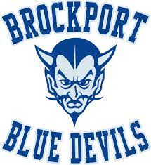

Save the Dates for Senior Year!
September 29th – Homecoming
October 27th - Senior Picture Submission
November 7th & 8th – Senior Superlatives
March 21st - 100 Days to Graduation
May 13th - Honor Roll Breakfast
May 22nd - Awards Night
May 23rd – Senior Breakfast & Yearbook Distribution
May 24th – Prom
June 6th – Senior Awards Night
June 7th – 9th Senior Trip
June 10^{th -} Paint Over your Parking Spot
June 13th - Senior Walk
June 15th Project Graduation
June 27th - Graduation Rehearsal
June 29th - Graduation

